H.T No
Regulations:
A17


Sreenidhi Institute of Science and Technology
(An Autonomous Institution)
Code No: 6A304 Date: 22-June-2019 (AN)

B.Tech II Year I-Semester External Examination, June-2019 (Supplementary)
Circuits and Networks-II (EEE)

Time: 3 Hours Max.Marks:75

Note: a) No additional answer sheets will be provided.
b) All sub-parts of a question must be answered at one place only, otherwise it will not be valued.
c) Missing data can be assumed suitably.

Part - A Max.Marks:25

Answer all QUESTIONS.

1. | What is the relationship between line quantities and phase quantities in a 3-phase system. | [3M]
2. | When a series RL circuit is connected to a constant voltage at t=0, what is the current passing through the circuit at t=0+? | [3M]
3. | What are the properties of the driving point function? | [3M]
4. | Express ABCD-parameters in Z-parameters. | [3M]
5. | Draw the constant-K band stop filter. | [3M]
6. | Compare Laplace and Fourier transforms in detail. | [2M]
7. | What is the condition for half wave symmetry? | [2M]
8. | In which three phase system the harmonics that are produced are circulated inside. | [2M]
9. | Define a port. Why two port network is more important? | [2M]
10. | What do you meant by a pole and zero of a function? | [2M]
Part – B Max.Marks:50
ANSWER ANY FIVE QUESTIONS. EACH QUESTION CARRIES 10 MARKS.

11. | a) | What are the advantages of three phase system. | [3M]
 | b) | A delta connected load when each phase has an impedance of 130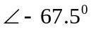in each phase. Find the magnitude and phase of all line currents If it supplies phase voltage of 390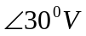 | [7M]
12. | a) | Find the complete response v and then i for t > 0 in the circuit shown below.  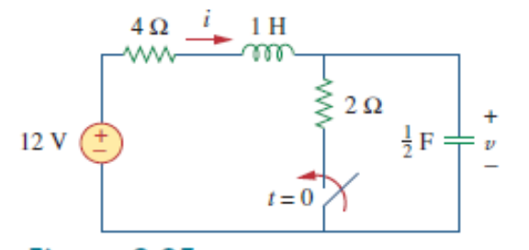 | [8M]
 | b) | What is the need to study transient behavior of the network | [2M]
13. | a) | Find the transform admittance of the network  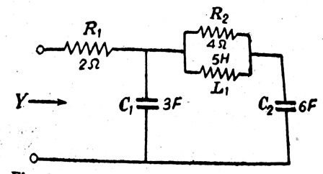 | [5M]
 | b) | transfer function is given by find the time domain response | [5M]
14. | a) | Two networks have been shown below. Obtain the transmission parameters of the resultant network.  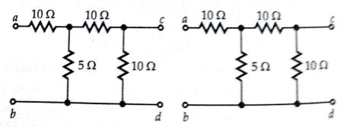 | [5M]
 | b) | Obtain the Z-parameters for the network shown below.  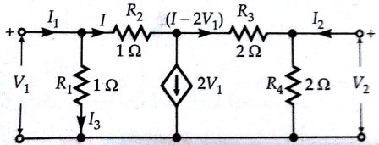 | [5M]
15. | a) | Design a T-section high pass filter having a cutoff frequency 10KHz and design resistance  R₀ = 600Ω. Find its characteristics impedances and phase constant at 25KHz | [5M]
 | b) | Design a constant-K high pass filter has a design impedance R₀ =600Ω, f_{C} =4KHz. (π-section) | [5M]
16. | a) | Find the Fourier series expansion of the Full rectified sine wave. | [7M]
 | b) | Write a short note on consideration of symmetry. | [3M]
17. | a) | The unbalanced Y-load has balanced voltages of 100 V and the acb sequence. Calculate the line currents and the neutral current. Take Z_{A} = 15 Ω, Z_{B} = 10 + j5 Ω, and Z_{C} = 6 -j8 Ω. | [5M]
 | b) | For the circuit below the switch has been closed for a long time. It is open at t=0. Find i(0⁺), v(0⁺),first derivative of i(0⁺) and v(0⁺).  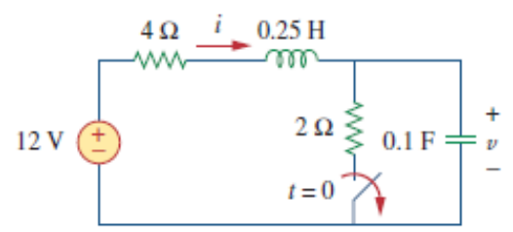 | [5M]
18. | a) | Design K-type band pass filter having a design impedance of 500Ω and cut-off frequencies 1KHz and 10KHz. | [7M]
 | b) | What is the major difference between M-derived and K-derived filters. | [3M]

-- 00 -- 00 –

